Pre-requisites

1. Java

2. server/instance with at least 2 gb of ram.

Installing JFrog artifactory in Ubuntu

**installing Java**

* sudo apt install openjdk-11-jdk

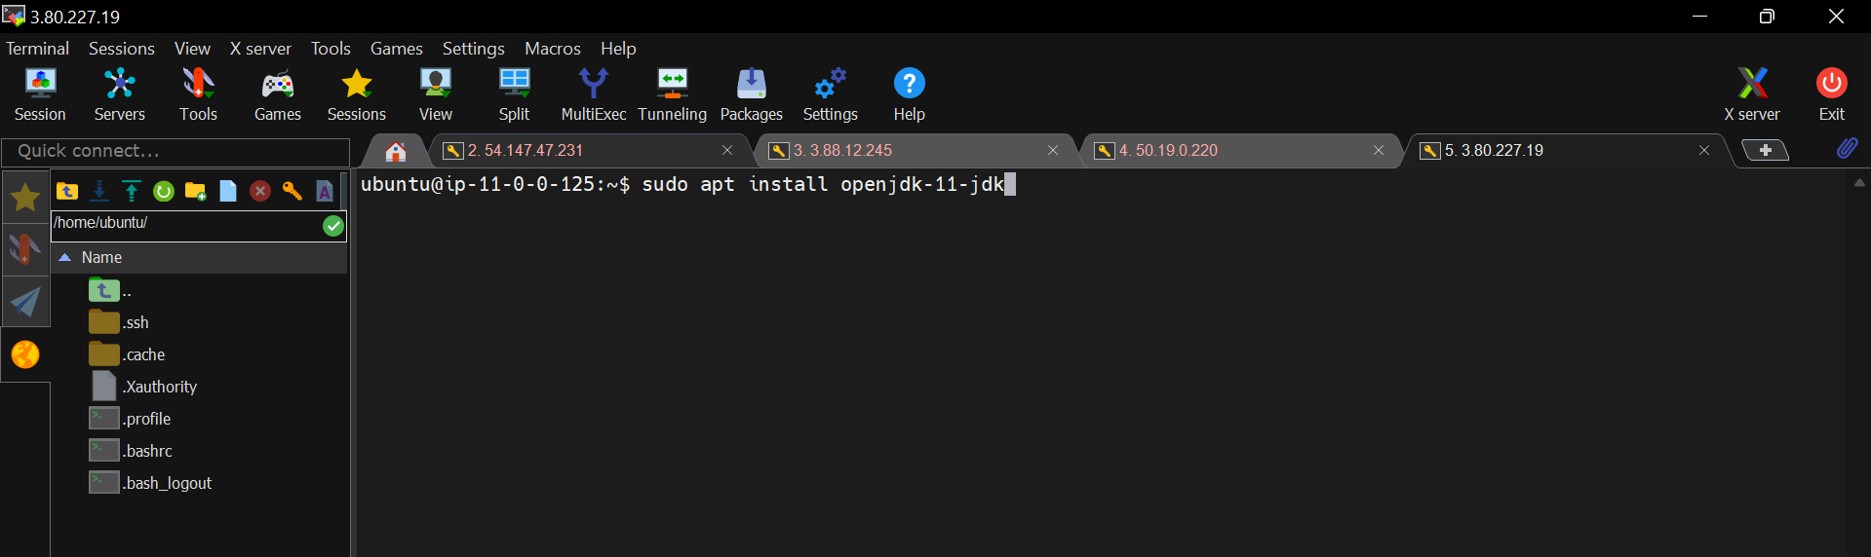

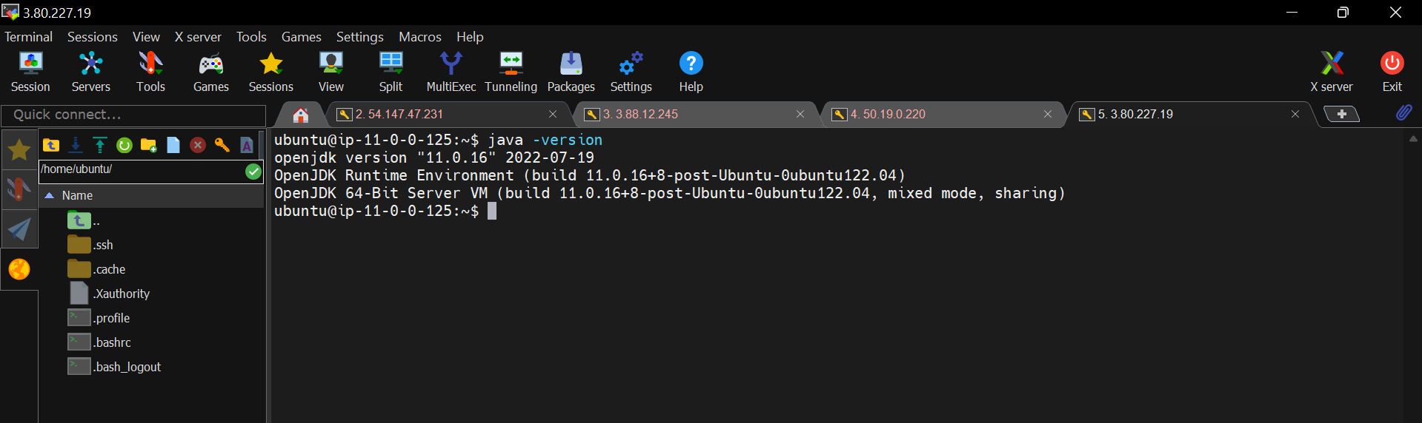

**Installing JFrog Artifactory**

* wget <https://releases.jfrog.io/artifactory/bintray-artifactory/org/artifactory/oss/jfrog-artifactory-oss/7.11.7/jfrog-artifactory-oss-7.11.7-linux.tar.gz>

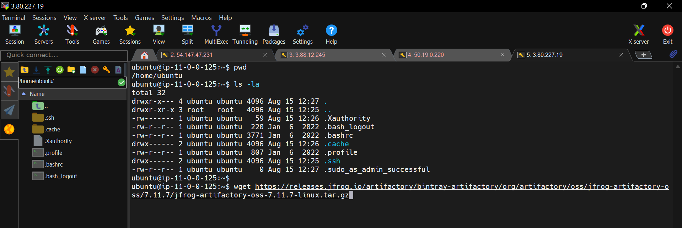

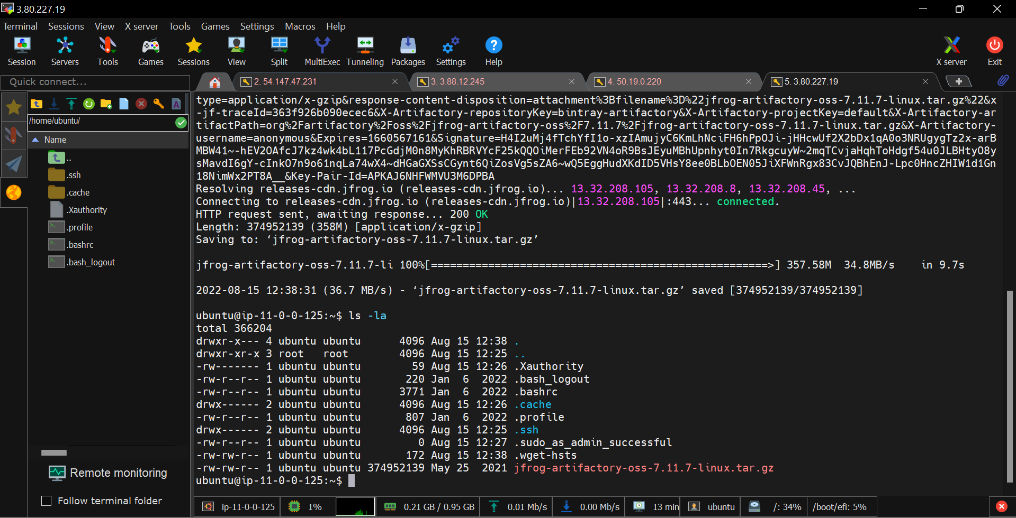

Now, un-tar the downloaded tar file.

* tar -xvzf jfrog-artifactory-oss-7.11.7-linux.tar.gz

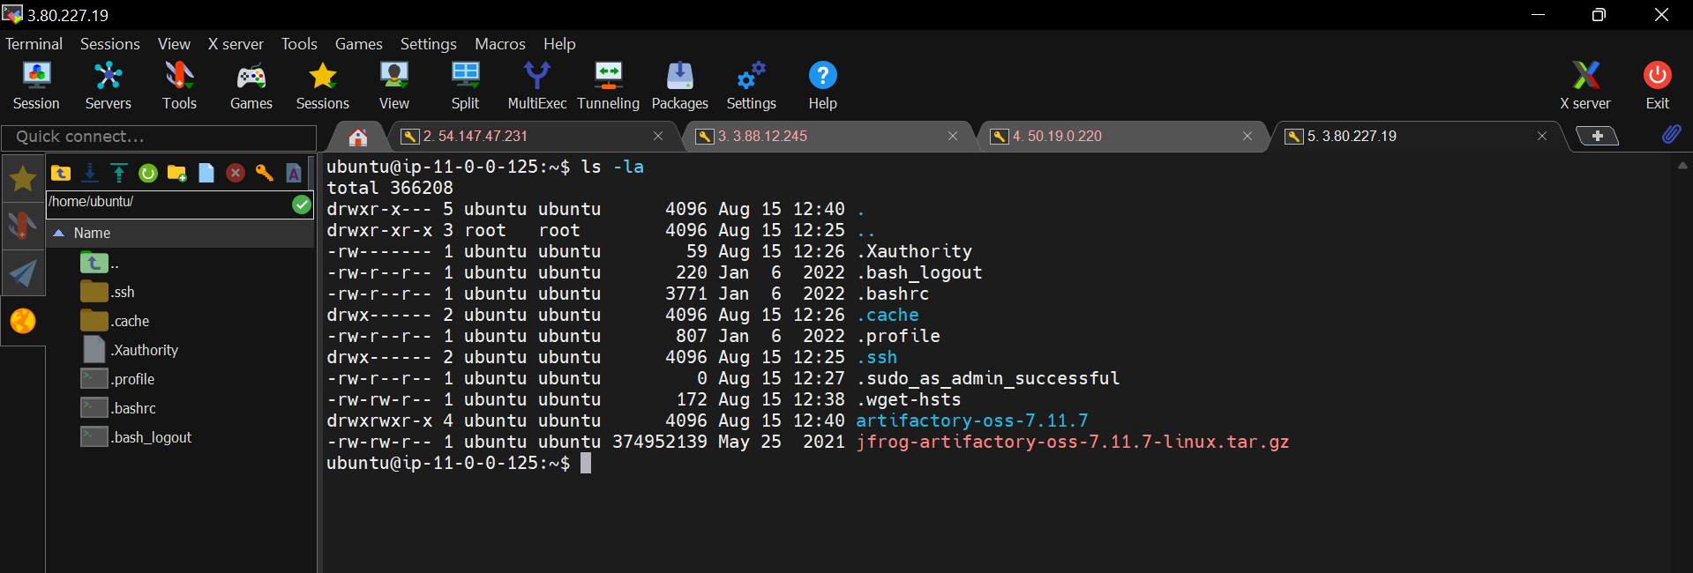

Un-tared directory.

Now, move this un-tared file to “/opt” directory.

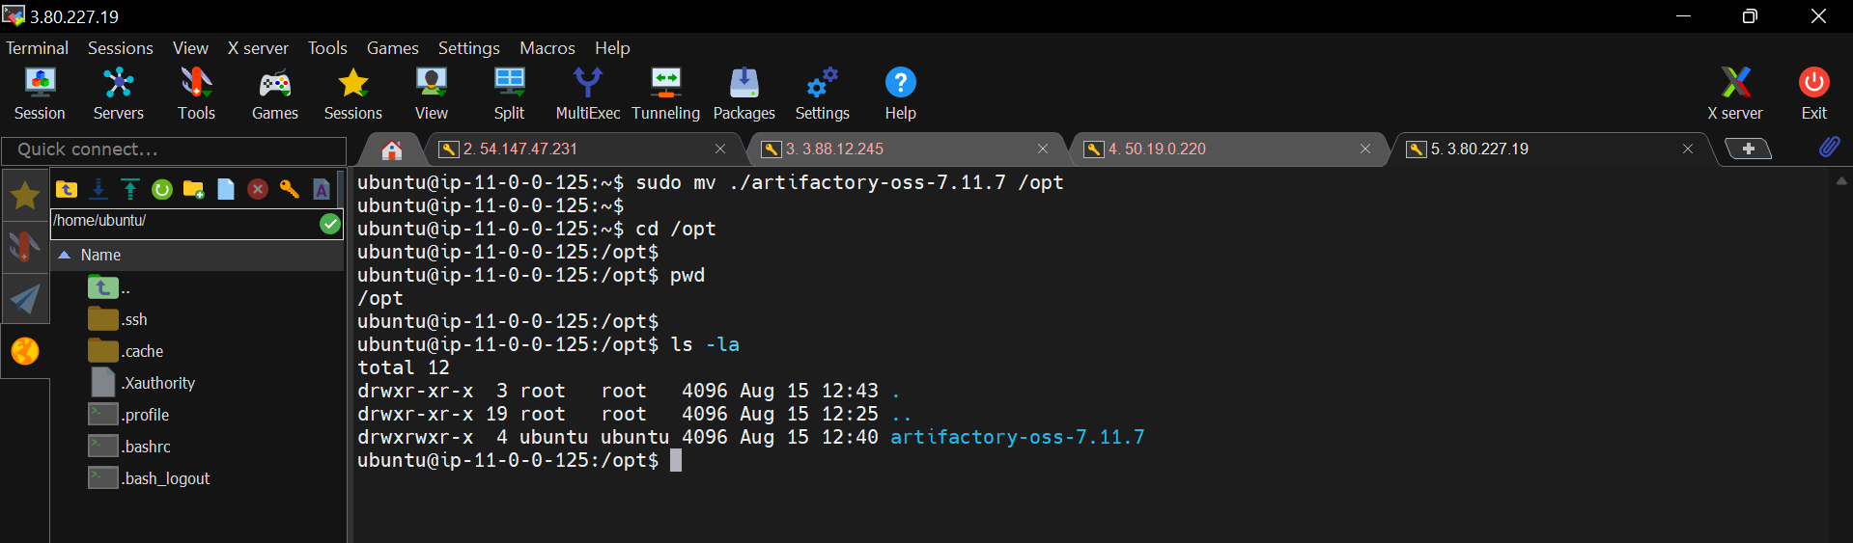

Now start the JFrog artifactory server.

* cd /opt/artifactory-oss-7.11.7/app/bin/

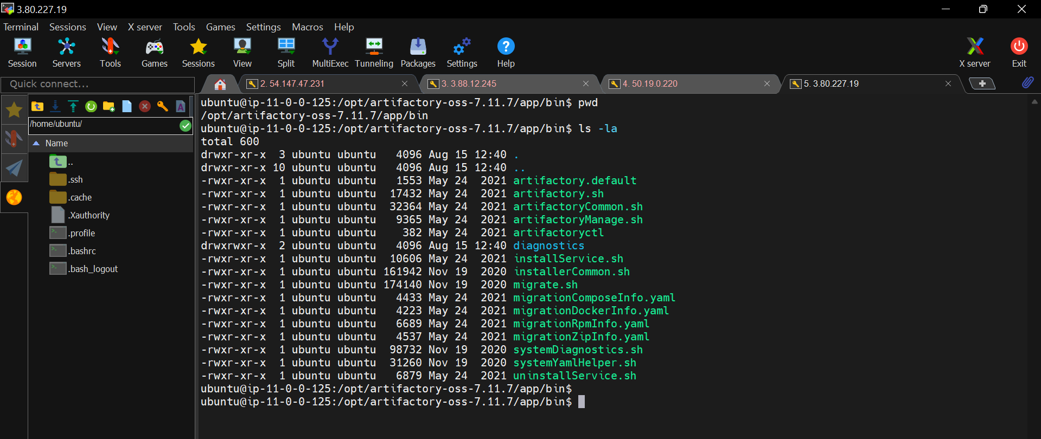

artifactory.sh is the file used to run the server.

* ./artifactory.sh start
* ./artifactory.sh status
* ./artifactory.sh stop

**Note:**

The default port number for artifactory server is 8081, but my tomcat server is already using that port number.

Now, let see how to change port number for JFrog artifactory.